Data Science Univariate Analysis
Assignment on Central Tendency for placement data:
Below tabulation is the result of Central Tendency with Mean, Median and Mode.
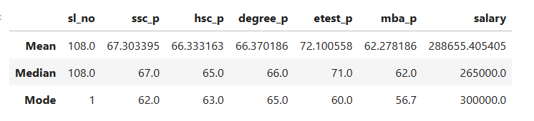

Observation based on the tabulation results:
- In this case fixing the salary range based on Median and Mode won’t help, as Median only find the mid of all and Mode only find the repeated marks.
- Mean is the only solution to identify the salary package for bunch of students based on their Marks scored in SSC, HSC, Degree, Entrance test and MBA.
- The average marks for all the pass students were below 70 in SSC, HSC, Degree, and MBA.
- They scored above 70% in Entrance test.
- Based on all these pass score their salary package is predicted as 2.8L.

